Introduction to Dynamo
The purpose of this document is to give engineers a glimpse into possible uses of Dynamo. In my experience, it is best to keep things as simple as possible where you understand each node and what data or parameters you are grabbing/entering. This guide will go through a few general items for which I have used Dynamo. The majority of my knowledge involves modifying text parameters within families.

Initial Setup
If you are creating a new script or using a script for the first time, I recommend testing in a local file.
If you are in a Workshared model, sync your model before going any further that way you have the ability to exit Revit without saving if something goes wrong.
After opening your project in Revit, go to the Manage tab and hit Dynamo on the far right.
Before opening any pre-existing files you might have, create a new file.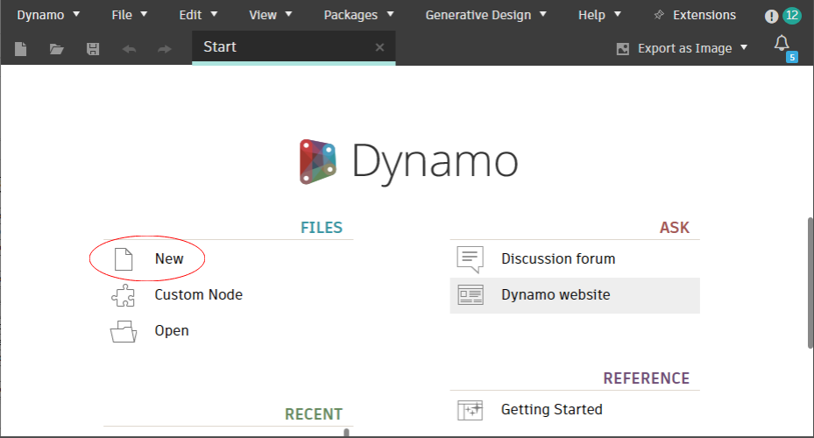
Make sure you set the run status in the bottom left to Manual. It defaults to Automatic, but you never want to have it set to Automatic. VERY IMPORTANT STEP.
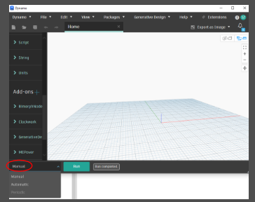
From now on, every time you open Dynamo, the run status should be set to Manual. You should not have to change this every time you open Dynamo, but you will have to update it the first time you open a new year of Revit.
At this point, you are pretty much free to do whatever you want. You can open an existing .dyn file you have or create one from scratch. There is a bunch of stuff online to help you learn/understand the functionalities of Dynamo. There are also plenty of files online if you want to use someone else’s file and adapt it to fit your needs. However, if you do not understand every node within someone’s Dynamo file, DO NOT USE IT. It is very easy to incorrectly reference things within Dynamo, so if you are unsure of what your script did, either CTRL+Z or exit the model without syncing.

Find/Replace Mark Example
This script can be found in the BIMCAD folder under “Mark Find and Replace.dyn”
This script allows you to select model elements and Find/Replace text within the Mark parameter of the selected elements. My workflow is as follows.
Let’s assume you have 40 generators with a naming convention such as 101-GENSET-01-X. Now let’s say the client prefers to have their generators named using a different naming convention such as 101-GEN-01-X. Extremely minor change, but you normally would have to click on each generator one by one and update the Mark on each one. Or you create an electrical equipment schedule, add family and type and Mark to the fields, and then modify each Mark within your schedule.
If you wanted to use Dynamo, you start by right clicking a generator, and selecting Select All Instances Visible in View. If you want to select elements that are in a different view, you will need to create separate view that shows every element in the same view.
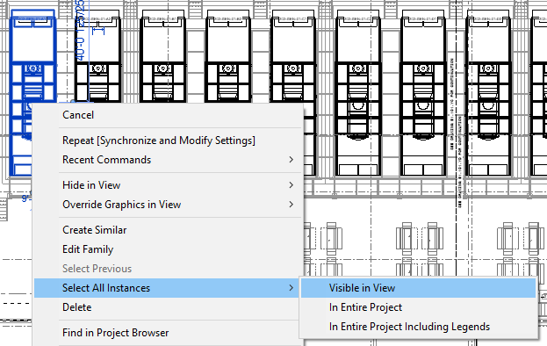

With your generators selected, hit the Temporary Hide/Isolate icon at the bottom of your screen (it’s the icon with the eyeglasses). Now hit Isolate Element.
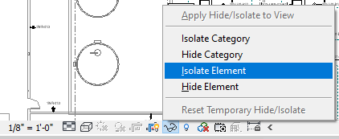
This isolates all of your generators in your view. From here, you can go Dynamo and click Select on the Select Model Elements node.
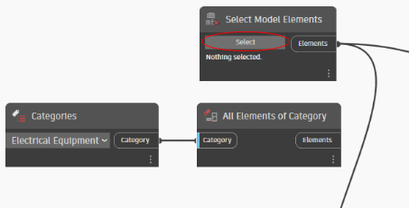
There are two unused nodes in this script – Categories and All Elements of Category. These can be used if you want to apply a Find/Replace to every single Electrical Equipment element in the model. This is helpful if you have a bunch of different find/replaces to do within different families. I use the temporary hide/isolate function to ensure I am not modifying things I do not want to modify.
IF YOU USE CATEGORIES AND ALL ELEMENTS OF CATEGORY NODE, MAKE SURE YOU ARE EXTREMELY AWARE OF THE NAMING CONVENTIONS OF EVERY ELEMENT WITHIN YOUR MODEL. NO ERRORS WILL BE THROWN AT YOU IF YOU FIND “-P” AND REPLACE IT WITH “-P1” AND YOU CHANGE ALL OF YOUR PANEL MARKS FROM 1-R-PNL-01 TO 1-R-P1NL-01. This is why I use the temporary hide/isolate function.
Once you have clicked Select on the Select Model Elements node, you can select the elements in your view using a selection box.
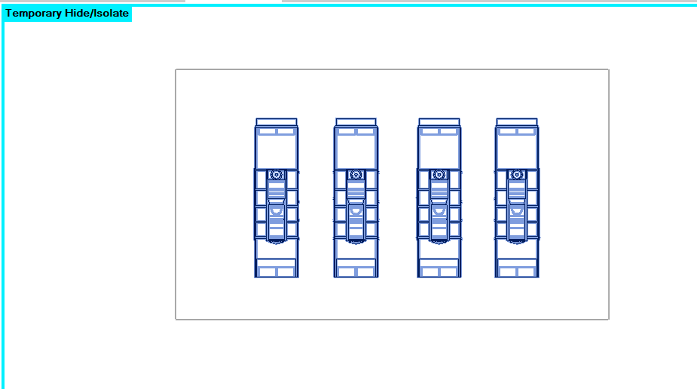
Now your elements have been selected, and you’ll notice the element IDs are shown in the Select Model Elements node.
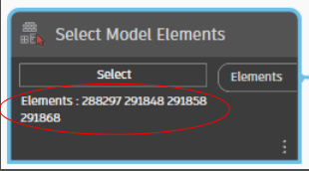
Next, enter the text you want to find into the String node with the text FIND, and enter the text you want to replace it with into the String node with the text REPLACE.
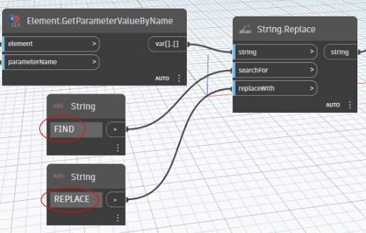
If you wanted to replace a different parameter such as the Comments, simply replace Mark with Comments in this node.
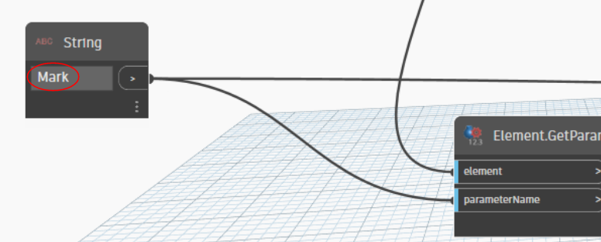
At this point, you can now hit run and all of the Marks within each element should have updated based on your find/replace.
